**Task Document**

**Github Url :** **https://github.com/prabodha72/prabodha72.git**

**MBG >> MBG Task(Main project)**

**MBG >> Script (Sql Queries)**

**Task Done with:- C# ,ASP.net MVC, ADO.net, SQL Server, bootstrap, js, jquery.**

**Please use Visual studio with Administrative mode.**

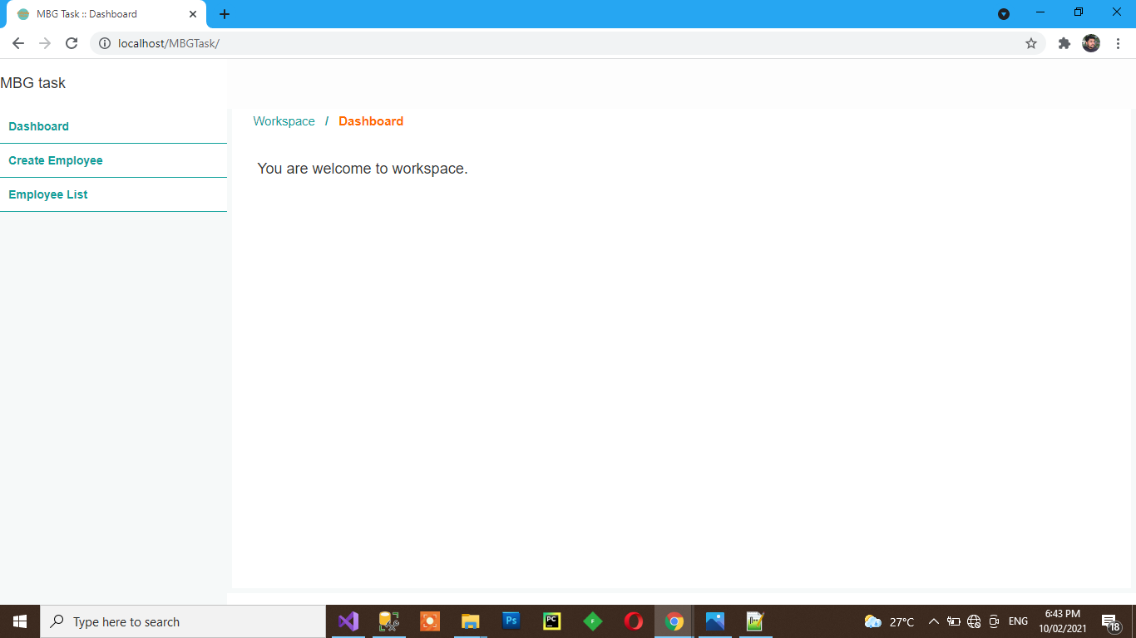

**Above screenshot is the start page of the project. Left side content required menus.**

**Now Click on Create Employee in menu list, it redirects to the Create Employee page and page looks like below screenshots.**

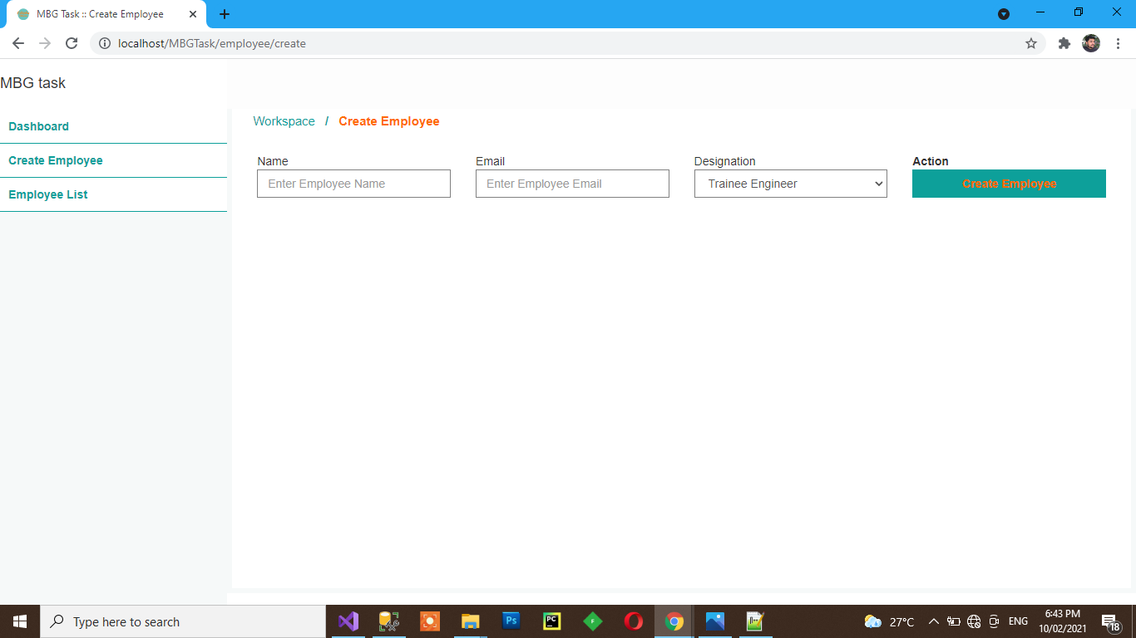

**All Fields are required field, after keying in Click create Employee button it saves employee records to the db.**

**Now Click on Employee list Menu item in left side, it redirects to the Employee list and page looks like below.**

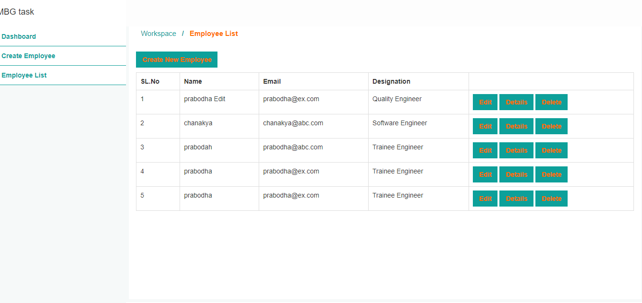

**Click on Edit button in table it redirects to the edit page. Edit page loaded the employee data do the edits and click on update employee button. Once it updates the data redirecting to the View Employee page.**

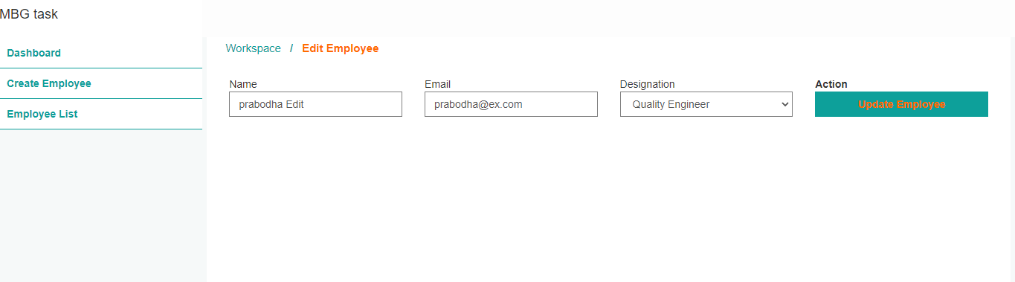

**On click Details button in Employee list table it redirects to the specific employee view page. And page looks like below screenshots. Top of the page there is a submenu to Edit Employee, Profile and Document.**

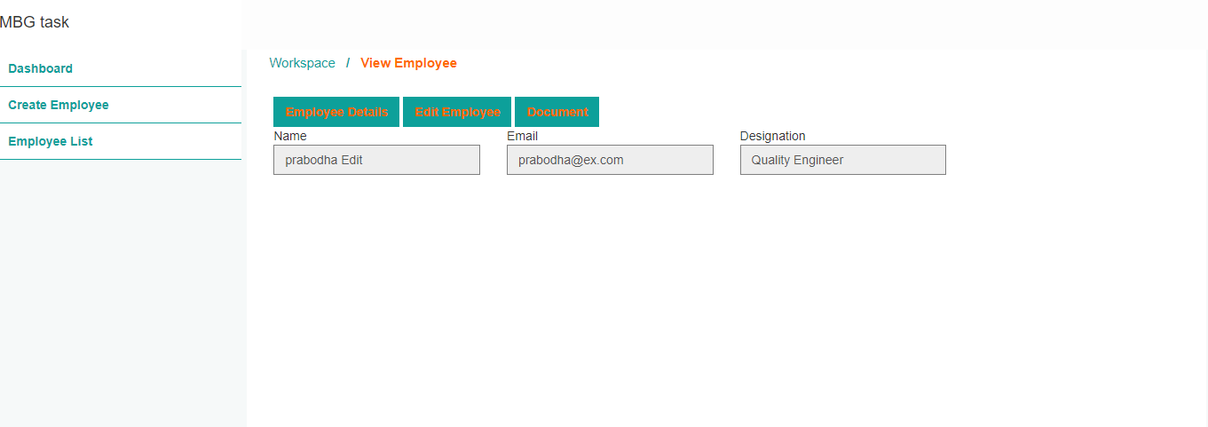

**By clicking on Edit Employee it redirects Edit Employee page and On Click Document button it redirects to the Employee Document page and page looks like below.**

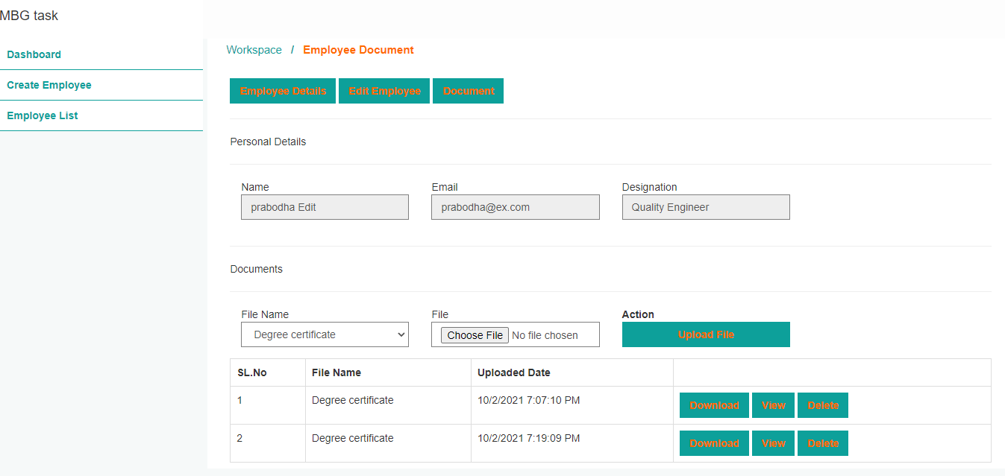 **Key in fields in Documents division. Then click on Upload File button. It Encrypts the file and encrypts the file path in db.**

1. **On click Download it downloads the particular attached file after decrypt.**
2. **On click View pdf doc shows in webpage.**
3. **On click delete button it deletes the Particular file.**
4. **On click Employee list table on delete it hard deletes the Employee record as well as all the related documents.**

**Database table scripts:-**

create database MBGtask;

use MBGtask;

create table Employee(

EmpId INT IDENTITY(1,1) PRIMARY KEY,

[Name] nvarchar(60),

Email nvarchar(100),

Designation nvarchar(50)

);

Create table EmployeeDetails(

EmpDetId int IDENTITY(1,1) PRIMARY KEY,

EmpId int foreign key references Employee(EmpID) ,

[FileName] nvarchar(max),

[FilePath] varbinary(max),

CreateDate datetime

);